|  |  |  |  |
| --- | --- | --- | --- |
| **F:\Learning bugs\Foundation Subjects\Dolly the Fly - Science.jpgLyng Primary School Knowledge Organiser** | | | |
| **Topic: Science** | **Micro-habitats**  How do microhabitats provide what minibeasts need to survive? | Year 2 | Autumn Term |

|  |
| --- |
| **Unit outcomes** |
| * Identify and name a variety of plants and animals. * Recall that minibeasts live in microhabitats. * Describe microhabitats and their conditions. * Describe how microhabitats provide for the basic needs of animals and plants. * Describe the job role of a botanist. * Group minibeasts and create simple classification keys. * Ask questions and recognise that they can be answered in different ways. * Gather and record data and use it to answer questions. * Plan what observations to make in an experiment. * Order the steps of a method. * Describe the appearance of flowering plants. * Use an identification chart to name flowering plants. |

|  |
| --- |
| **Key skills** |
| * Posing questions * Planning * Predicting * Observing * Recording * Classification keys * Analysing and drawing conclusions |

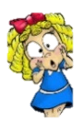

|  |  |
| --- | --- |
| **What Goldilocks and Step On words will I use?** | |
| **Spelling** | **Definition** |
| Botanist | An expert in the scientific study of plants. |
| Characteristics | A feature or quality belonging to a person, place or thing. |
| Classify | Arrange in classes or categories according to shared qualities or characteristics. |
| Conclusion | The end or finish of an event or process. |
| Data | Facts and statistics collected for analysis. |
| Identify | Establish what who or what something is. |
| Camouflage | Hide or disguise the presence of a person or animal. |
| Classification key | A set of questions about the characteristics of a living, which then help you to identify it. |
| Food chain | A series of organisms dependent on the next source of food. |
| Invertebrate | An animal without a backbone. |

|  |
| --- |
| **Key questions – sequence of learning** |
| * How can we group and identify mini beasts? * How do scientists ask questions? * What mini beasts are in the school ground? * Do woodlice prefer dry or damp conditions? * How can I record data in a table? * What is a botanist? |

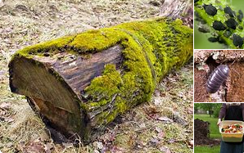

“An understanding of the natural world and what’s in it is a source of not only a great curiosity but great fulfilment.”

-David Attenborough

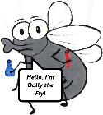

**What will I know by the end of the unit?**

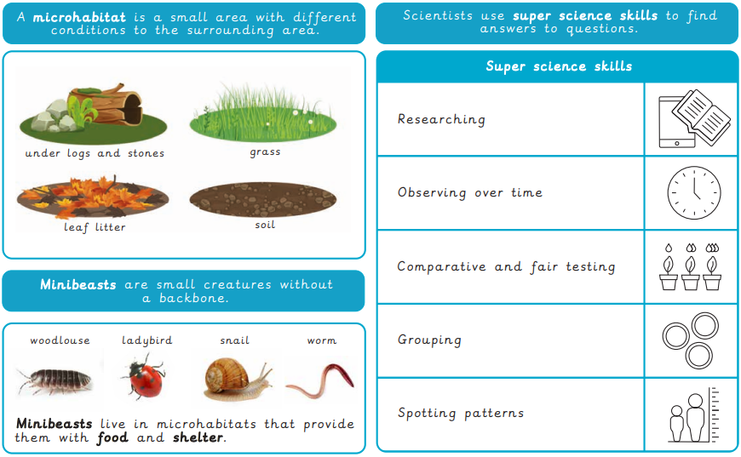

|  |  |  |  |
| --- | --- | --- | --- |
| **F:\Learning bugs\Foundation Subjects\Dolly the Fly - Science.jpgLyng Primary School Knowledge Organiser** | | | |
| **Topic:** | **Science**  **Micro-habitats** | Year 2 | Autumn Term |

|  |  |  |  |
| --- | --- | --- | --- |
| 1. Which of these is **not** an example of a microhabitat? | **S** | | **E** |
| Under a log |  |  | |
| The ocean |  |  | |
| Under fallen leaves |  |  | |
| In the grass |  |  | |

|  |  |  |
| --- | --- | --- |
| 4. Where do woodlice prefer to live? | **S** | **E** |
| Somewhere damp |  |  |
| Somewhere dry |  |  |
| Somewhere hot |  |  |
| Somewhere cold |  |  |

|  |  |  |
| --- | --- | --- |
| 2. Which of these might you find in a microhabitat? Tick two. | **S** | **E** |
| Worm |  |  |
| Lion |  |  |
| Ladybird |  |  |
| Shark |  |  |

|  |  |  |
| --- | --- | --- |
| 5. Which of these is not a mini-beast? | **S** | **E** |
| Caterpillar |  |  |
| Spider |  |  |
| Cat |  |  |
| Worm |  |  |

|  |  |  |
| --- | --- | --- |
| 3. What is a mini beast? | **S** | **E** |
| An animal with a backbone |  |  |
| An animal without a backbone |  |  |
| An animal with wings |  |  |
| An animal with a four legs |  |  |

|  |  |  |
| --- | --- | --- |
| 6. Which super science skill would you use for carrying out a mini-beast hunt? | **S** | **E** |
| Researching |  |  |
| Observing over time |  |  |
| Grouping |  |  |
| Spotting patterns |  |  |